

**COMSATS University Islamabad, Lahore Campus**

**02 October 2022**

**Assignment TSE**

| Course | | | Topics in Software Engineering | | | | |
| --- | --- | --- | --- | --- | --- | --- | --- |
| Assignment # | | | 01 | | | | |
| Submitted To : | | | Ma’am Fatima Sabir | | | | |
| **Group Members** | | | | | | | |
| Sr.# | Reg. # | Student Name | | CGPA | Email ID | Phone # | Signature |
| (i) | **Fa19-BSE -088** | **Furqan Rasool Yahya** | |  | **fa19-bse-088@cuilahore.edu.pk** |  |  |
| (ii) | Fa19-BSE- 074 | Ubaid Shah | |  | fa19-bse-074@cuilahore.edu.pk |  |  |
| (iii) | sp19-bse- 033 | Amir Fiaz | |  | sp19-bse-033@cuilahore.edu.pk |  |  |

# 

**(a)identify these issues**

**(i)Identify deprecated technology or APIs**

Java should not be used for app development, developers should program in react native or swift .Beyond Java 8 there isn’t anything worth writing home about. Java is losing its original intent, set by Gosling at the time, that it should be simple to grasp. That’s no longer the case, if you use all the latest greatest features.

**(ii)Potential Issues**

Beyond Java 8 there isn’t anything worth writing home about. Java is losing its original intent, set by Gosling at the time, that it should be simple to grasp. That’s no longer the case, if you use all the latest greatest features.

**(iii)missing technical documentation**

There are some prototypes of modules missing in the document which should be included , rather than this nothing is missing in the document.

**(b) PMD**

**(i)Issues Viewed from Editor**

Useless class

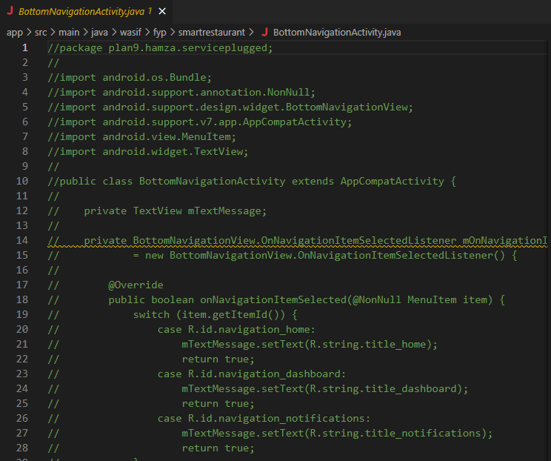

**(ii)Track & prioritize**

* Line is longer than 100 characters This Consumes Memory.
* Switch statements should be exhaustive, add a default case (or missing enum branches) so error handling can be done .
* Lexicographical order is not followed in many files of the code.

**(iii)Code Quality**

* Unnecessary commenting is being used.
* Declared but unused variables in all over the code.
* There are no Indentation styles used in code.

**(iv) Apply at least 3 PMD rules with the help of tool**

**Static Analysis**

*override one parent and inside it i call other parent implementation*

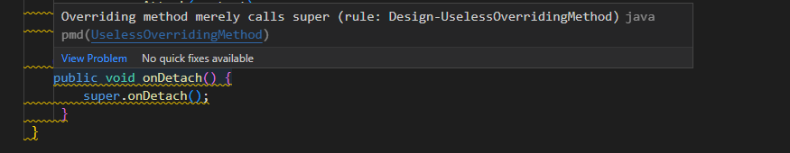

*Constructor not used > unnecessary*

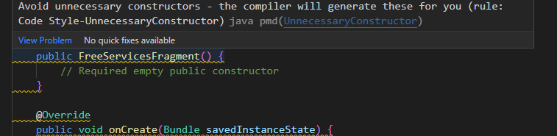

*Name does not match convention rule*

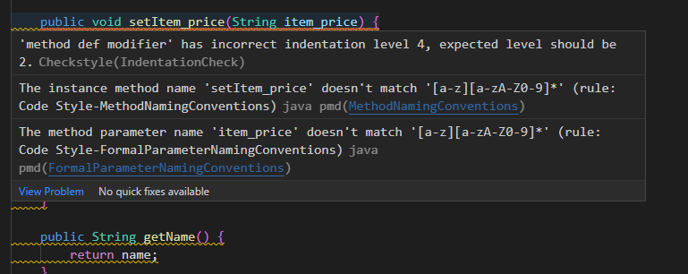

**(v)Abstract Syntax Tree**

**SigninActivity.ast**

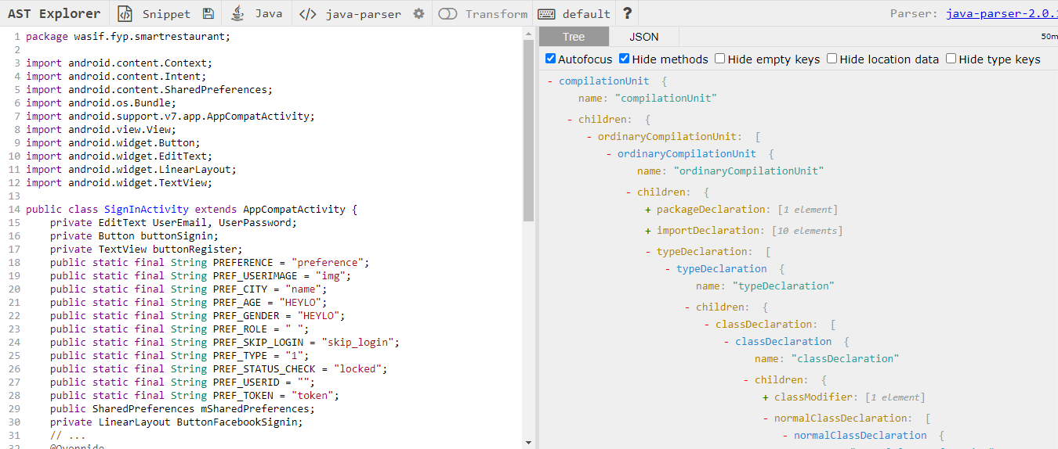

**RegisterActivity.ast**

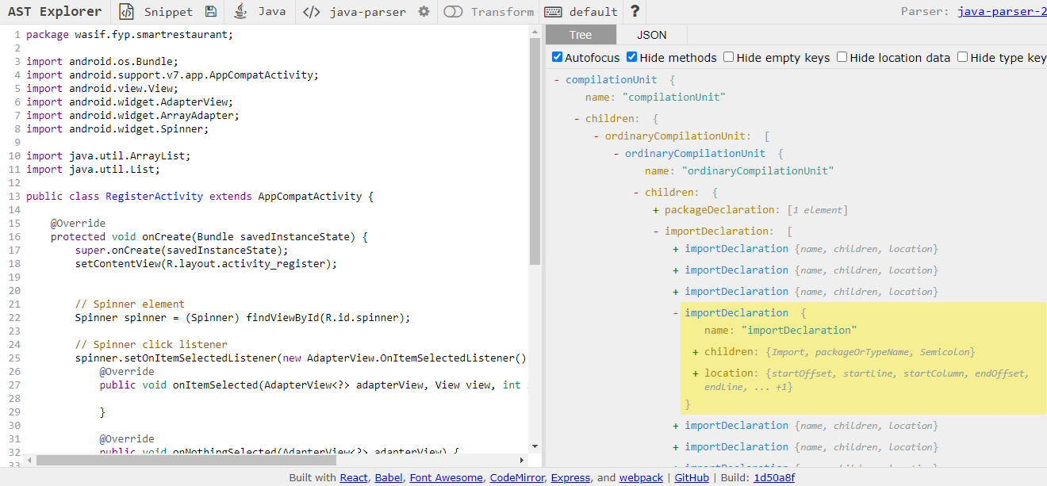

**(c) Check Style Plugin**

**member def modifier' has incorrect indentation level 4, expected level should be 2.Checkstyle(IndentationCheck**

**Indentation is not properly done in SigninActivity.java file**

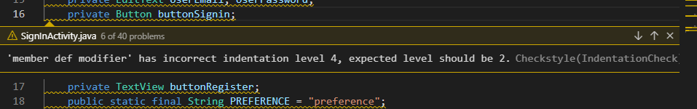

**Abbreviation in name 'GPSTracker' must contain no more than '2' consecutive capital letters.Checkstyle(AbbreviationAsWordInNameCheck)**

**GPSTracker should be renamed to Gpstracker**

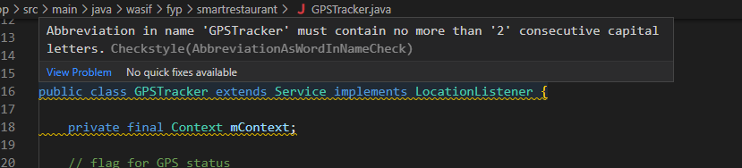

**'method def modifier' has incorrect indentation level 4, expected level should be 2.Checkstyle(IndentationCheck)**

